On 9th April, 1917, The Brisbane Courier reported, “King Solomon, of the Larrakia tribe, a very picturesque and old Darwin identity, died on Saturday afternoon.” The old man was described as “being of an exceedingly kindly disposition”. Ten days later, on Thursday 19 April, the Northern Territory Times and Gazette described a “coronation ceremony” to appoint a successor to the late King Solomon. The newspaper reported that Solomon's only son, Frank, “magnanimously waived any claims to the succession”, allowing his brother George to accept the role as leader of the Larrakia people.

Obviously, the Larrakia people did not have “Kings”; however, research for land claims in the 1970s indicate that the patrilineal royal line espoused by the popular media coincides with the traditional ownership of the Darwin area by the Danggalaba clan, under George, Frank and their siblings.

The Northern Territory Times and Gazette reported on 27 September 1917 that “His Majesty King George, of the Larrakeyah tribe” had married “Kitty” in the presence of distinguished guests. When called upon to make a speech, the paper stated, “King George relegated this embarrassing duty to his Private Secretary, Frank Solomon (native cognomen Berryooin), a son of the late King Solomon.”
The report on the wedding may have been the origin of the surname “Secretary” which has been passed on through several generations of Frank's descendants. His Larrakia name was apparently taken from the sacred spring across the harbour known as “Belyuen”.

However, the surname “Secretary” was not fixed by 1922 when The Sun headlined “Black Printer's Devil. King Solomon's Son. Spear in Wife's Stomach” (presumably the woman was Frank's wife, Lucy). The report continued: “The accused is the son of King Solomon, the autocratic ruler of the Larrakeyah Tribe, who was noted for his suave and gentlemanly conduct.” The author Ernestine Hill also mentions Frank as an employee of the NT Times newspaper in Darwin and a photograph of “King Frank” standing outside the newspaper office is included in the Ernestine Hill Collection, University of Queensland, Fryer Library.

By 1953, at the time of his death, Frank's surname “Secretary” seems to have been officially adopted. The Argus reported on 8 June, 1953: “Old native 'chief'' dies. Frank Secretary, one-time chief of the Waugite tribe, died in the Bagot Native Reserve at the weekend. Frank who preferred the white man's way of life, gave up the leadership of the tribe to his brother more than 30 years ago. He became a printer's 'devil' and paper delivery boy on the 'Territory Times' which went out of existence 20 years ago. He was believed to have been more than 60 at the time of his death.”

King George died in Katherine in 1945. His son is listed in a Commonwealth Census of Wards as “Prince of Wales” AKA “Mudpul” or “Prinswel”, sometimes written as Midpul, “Mudpool” or “Midt-Pul”, born in 1940. The death of King George when his son was only five years of age left a leadership vacuum in the Larrakia tribe. When the need for strong leadership arouse during unrest among Darwin Aboriginal workers, a man named Lawrence Werrben, or “Urban” claimed he was “acting king”, as described in The Argus, on 17 January1951. Shortly after confrontational strike action led to the arrest of Lawrence, a Larrakia elder stepped into the role. His name was Fred Nadpur, also known as Fred Waters.

It appears that both Lawrence and Fred Waters acknowledged the Larrakia line of succession from King George to his son Midpul, known as “The Prince of Wales”. Lawrence was described as “acting King” and Waters as “Regent”. A letter from the Queensland Trades and Labour Council in 1951 claimed that Fred Waters was, “Regent” for the Larrakia tribe under Larrakia tribal law until “the hereditary heir, Little Fretwell, now a boy of 14, at Delissaville, takes over”. Obviously, “Little Fretwell” mentioned in the correspondence is the acknowledged successor to King George, named Midpul, or colloquially as “Princewel” which had been transcribed as “Fretwell” by the correspondent. Midpul, however, does not appear to have assumed a leadership role amongst the Larrakia before his death in 2002, although he was a key figure in the long-running Kenbi land claim to Cox Peninsula.

In his book, “A Drop of Rough Ted”, Ted Egan writes:
“[Fred Waters] planned to set Prince up as the new 'King'. Hence the name. Tribal politics were not for the irrepressible Prince, however and in all the time I have known him he has just drifted along, always having a bit of a laugh, never taking things too seriously, ever ready to negotiate a loan. Long live the Prince of Wales.”

In his lifetime, King George spoke strongly for his people. Both the “Kenbi Land Claim Book” (Brandl, Haritos & Walsh, 1979, pages 269-270) and Judge Mansfield (2006, pp. 94-95) quote The Northern Standard, 24 March 1936: “King Ichungarrabilluk (better known as King George) of the once great tribe of Larrakeeyahs, who roamed our foreshores from Point Charles to East Point in the day before the white invasion, hunting, fish, dugong, and turtle in their native canoes, called the old men of the tribe together … King George pointed out that they had heard reports that the Government intended to shift the present compound to some point inland to make way for more Myilly Point residences.

“The Larrakeyah people are a salt water tribe and would not be prepared to live away from the sea”, said King George. “This is all the country we have left, and the Government should leave us on it. Years ago we use to have our camping grounds on Lamaroo Beach and I was born there as were most of the old men of the tribe. Our water supply was the native well where the present baths are now located. When Doctor Basedow and Dr. Gilruth shifted us to this place they promised us certain things but those promises were never kept. We have cleared this land and built our houses, and we should not now be asked to shift.”

After the death of Nadpur, the leadership role amongst the Larrakia seems to have remained vacant until 1971, when Frank Secretary's son, Bobby Secretary, assumed the role his father had abdicated as spokesperson for the Larrakia people. His battle is described in the book, “Bunji: a story of the Gwalwa Daraniki Movement” published by Aboriginal Studies Press, Canberra, in 1994.

In his 1968 book, “The Front Door”, author Douglas Lockwood wrote: “If finders were keepers, Darwin would belong to Gwila-marinya, known as Bob Secretary, of the Larrakia tribe of Australian Aborigines. His tribesman, George Mungalo, says: 'Bob Secretary is the big boss of Darwin. This is his country. It belonged to his father before, and that one's father before him … before the white man came.'”

Before his passing in 1984, Bobby Secretary was able to receive on behalf of his people the lease to 301 hectares of the land his uncle King George had chosen in suburban Darwin, stretching from Ludmilla Creek to Totem Road and known to the Larrakia as Kulaluk.
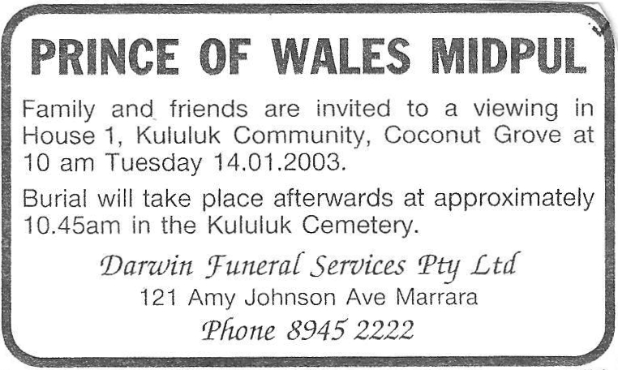

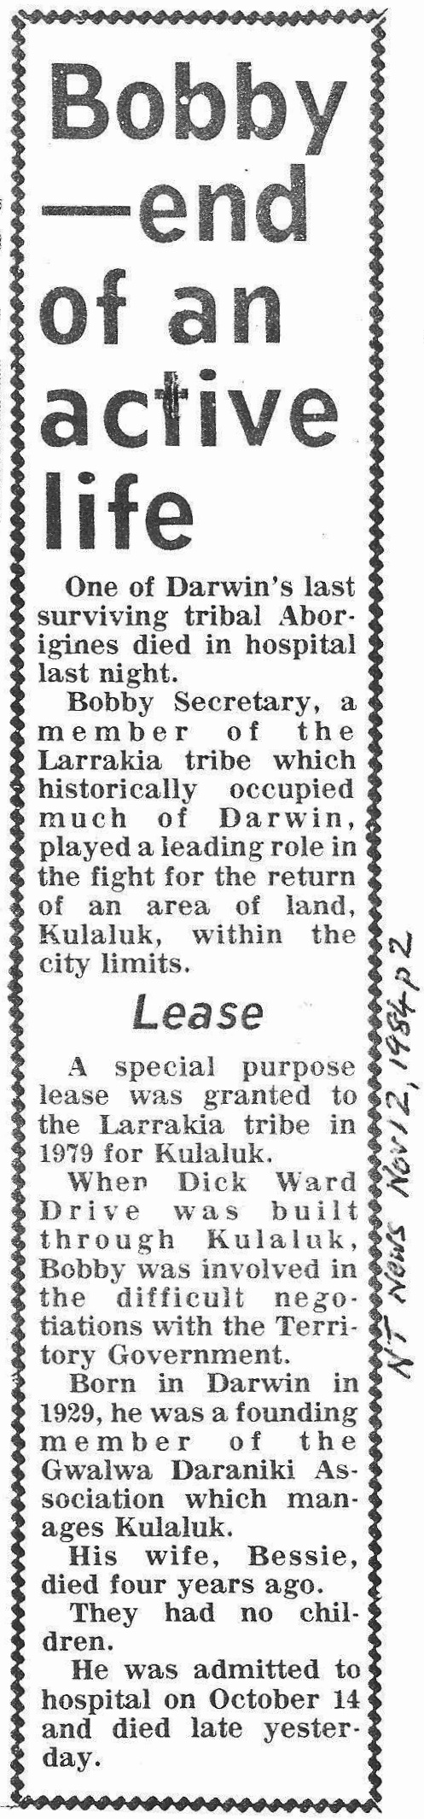
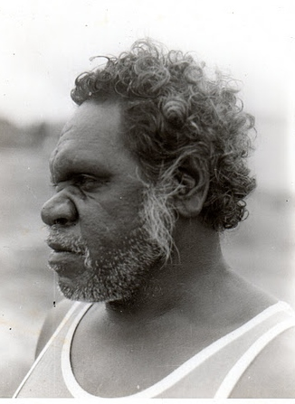

Prince of Wales 1978

